Problem Scenario: Unable to retrieve object which has multiple association between two objects

While creating a logical model, if the model contains a scenario wherein there are more than one association between two objects (as shown below) the generated code does not work appropriately. The problem exists in two places 1) Generated Java Beans and 2) Application Service layer’s search method which accepts SDK specific nested search criteria.

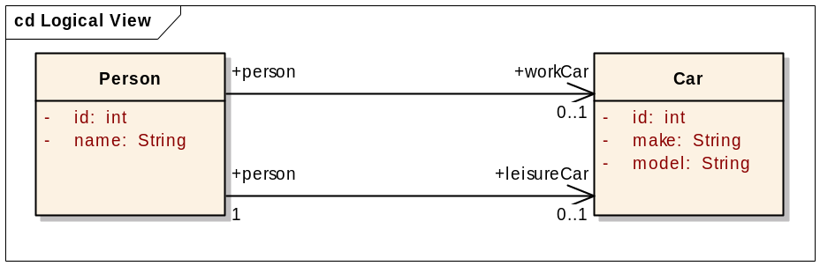

Java Beans

Below is the sample code for the Java Bean generated by SDK from the UML model (see above). Here the generated method retrieves associated object based on the search method from the application service layer.

private Car workCar = null;
public Car getWorkCar (){
ApplicationService appService = ApplicationServiceProvider.getApplicationService();
try {
Person thisIdSet = new Person();
thisIdSet.setId(this.getId());
java.util.Collection resultList = appService.search("Car", thisIdSet);
if (resultList!=null && resultList.size()>0) {
workCar = (Car) resultList.get(0);
}
}catch(Exception ex){
ex.printStackTrace();
}
return workCar;
}

private Car leisureCar = null;
public Car getLeisureCar (){
ApplicationService appService = ApplicationServiceProvider.getApplicationService();
try {
Person thisIdSet = new Person();
thisIdSet.setId(this.getId());
java.util.Collection resultList = appService.search("Car", thisIdSet);
if (resultList!=null && resultList.size()>0) {
leisureCar = (Car) resultList.get(0);
}
}catch(Exception ex){
ex.printStackTrace();
}
return leisureCar;
}

The generated code for getWorkCar and getLeisureCar has same code for retrieving the associated Car object. However, the generated code does not specify which Car object to fetch. Since two different methods to fetch two different associated objects of the same type is having identical code, it always returns identical result.

Search Method
There are many different search methods in caCORE SDK which accepts search query in different formats. The search methods which accept DetachedCriteria, HQL search criteria and SDK specific simple search criteria is not affected by this problem in anyways.

SDK specific nested search criterion allows navigating through the object tree without executing query for each association. A nested search is one where a traversal of more than one class-class association is required to obtain a set of result objects given the criteria object. This example demonstrates one such search in which the criteria object passed to the search method is of type Person, and the desired objects are of type Tire. Because there is no direct association between these two classes, the path of the traversal is passed to the search method enabling the query to be performed.

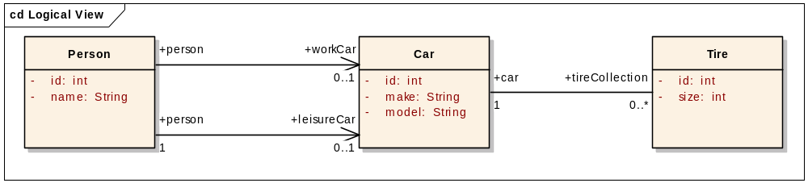

Person

Suggested Solution:

